Command model

# 1 System description

Model of the supervision. This model main goal is to convert and dispatch the torque command.

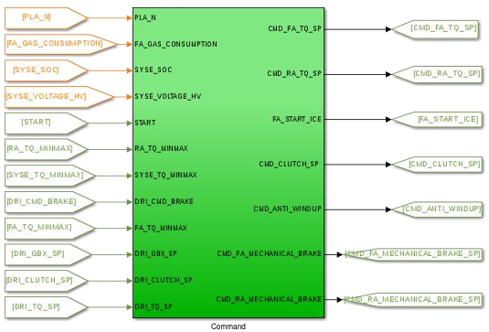

# 2 System organization

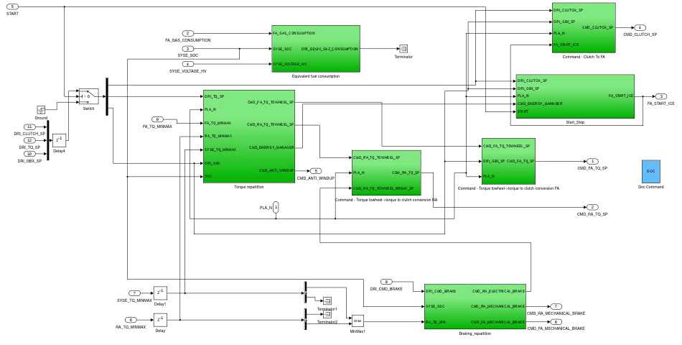

Model browser

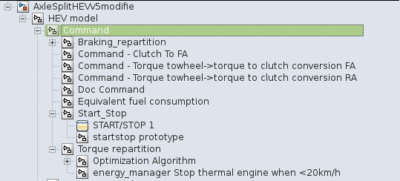

# 3 Signals and parameters

## Inputs

|  |  |  |
| --- | --- | --- |
| Name | Description | Note |
| PLA_N | Wheel speed | In RPM |
| RA_TQ_MINMAX | Minimum and maximum torque of the electrical machine | Normalized torque “to wheel”,  two signal:   * RA_TQ_MIN * RA_TQ_MAX |
| SYSE_TQ_MINMAX | Minimum and maximum torque for the electrical system | Normalized torque “to wheel”,  two signal:   * SYSE_TQ_MIN * SYSE_TQ_MAX |
| FA_TQ_MINMAX | Minimum and maximum torque for the ICE | Normalized torque “to wheel”,  two signal:   * FA_TQ_MIN * FA_TQ_MAX |
| DRI_CLUTCH_SP | Clutch pedal value | Range [0, 1] |
| DRI_GBX_SP | Gearbox engaged gear | For a manual gearbox |
| FA_GAS_CONSUMPTION | Instantaneous gas consumption | - |
| SYSE_SOC | Li-Ion battery state of charge | Range [0,1] |
| SYSE_VOLTAGE_HV | Voltage on the HV network | - |
| DRI_TQ_SP | Torque request from the driver | - |
| FA_START | Command variable to start the ICE from the driver | Binary |
| DRI_CMD_BRAKE | Command variable to brake | Normalized torque “to wheel” in N.m (positive) |

## Outputs

|  |  |  |  |
| --- | --- | --- | --- |
| Name | Description | Note | Destination |
| CMD_FA_TQ_SP | Torque set point for the ICE | N.m | Front axle |
| CMD_RA_TQ_SP | Torque set point for the electrical machine | N.m | Rear axle |
| FA_START_ICE | Command to start the ICE | - | Front axle |
| CMD_CLUTCH_SP | Clutch command | - | Front axle |
| CMD_ANTI_WINDUP | Anti-windup command |  | Driver |
| CMD_FA_MECHANICAL_BRAKE_SP | Torque set point of mechanical brake of front axle | N.m (positive) | Front axle |
| CMD_RA_MECHANICAL_BRAKE_SP | Torque set point of mechanical brake of rear axle | N.m (positive) | Rear axle |

## Parameters

### Native

|  |  |  |  |  |  |
| --- | --- | --- | --- | --- | --- |
| Name | Type | Unit | Description | Source | Linked to |
| cmd_equivalent_conso_coef | var | - | Coefficient for equivalent fuel consumption | Continental |  |
| cmd_qmax | var | Ah | Maximum charge | Continental |  |
| cmd_specific_volume_l_per_g | var | l/g | Gasspecific volume | Continental |  |
| cmd_torque_repartition | var | - | Coefficient for torque repartition | BEI N7 2014 |  |

### Inherited

|  |  |  |  |
| --- | --- | --- | --- |
| Name | Type | Unit | Description |
| fa_gearbox_efficiency | var | - | Gearbox efficiency |
| fa_differential_ratio | var | - | Front axledifferential ratio |
| fa_gearbox_ratio | vector | - | Gearbox ratio table |
| pla_max_f_brakes | var | N | Brakes maximum force |
| ra_differential_ratio | var | - | Rear axle differential ratio |
| ra_transmission_efficiency | var | - | Rear axle differential efficiency |

# 4 Subsystems description

Torque repartition

Repartition of the toque between the two axle and the brakes, with saturation applied.

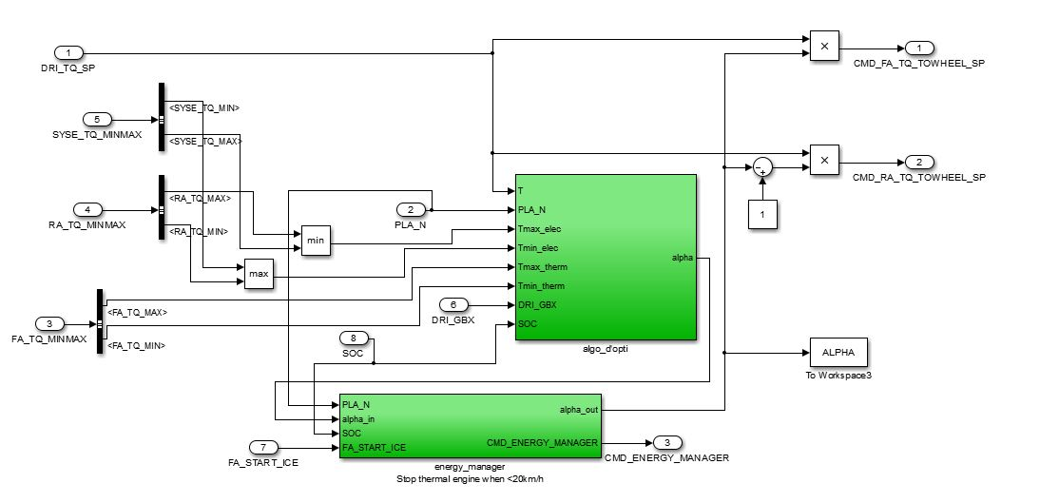

* Optimization algorithm: Calculates the torque repartition coefficient.
* Energy manager: Stops thermal engine under 20 Km/h.

Braking repartition

Brake of rear axle distribution between electrical braking and mechanical braking.

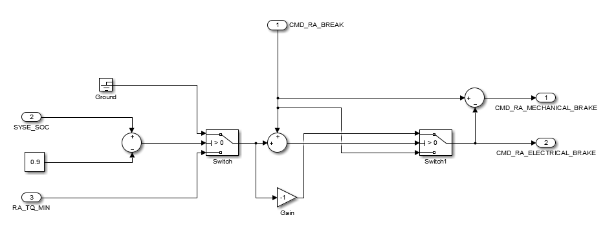

*Note:*

*This brake repartition is designed for a decoupled brake pedal technology.*

Command- torque to wheel-> torque to clutch conversion FA

Conversion of torque value at the wheel to combustion engine (ICE)

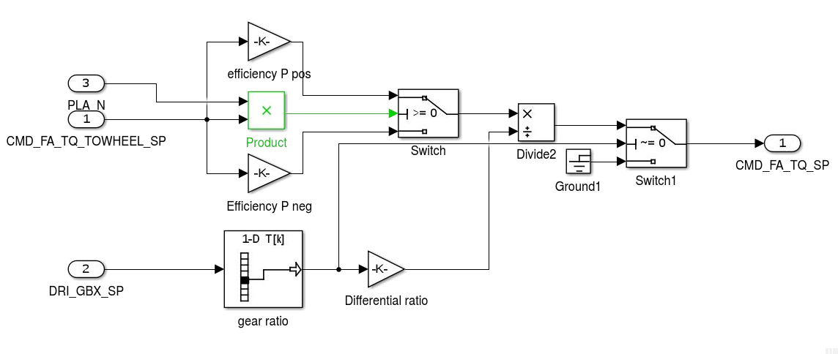

Command- torque to wheel-> torque to clutch conversion RA

Conversion of torque value to the wheel to electric motor.

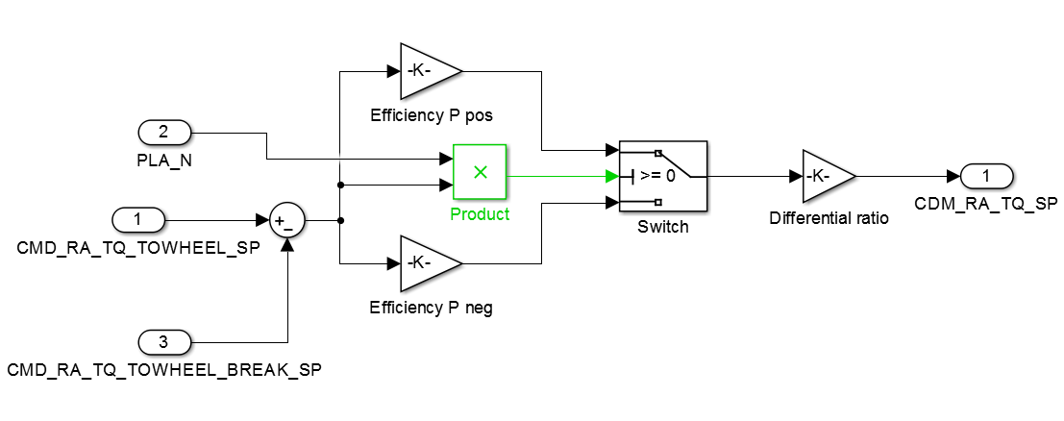

Equivalent fuel consumption

Equivalent fuel consumption following the standard. Used to optimize the torque repartition.

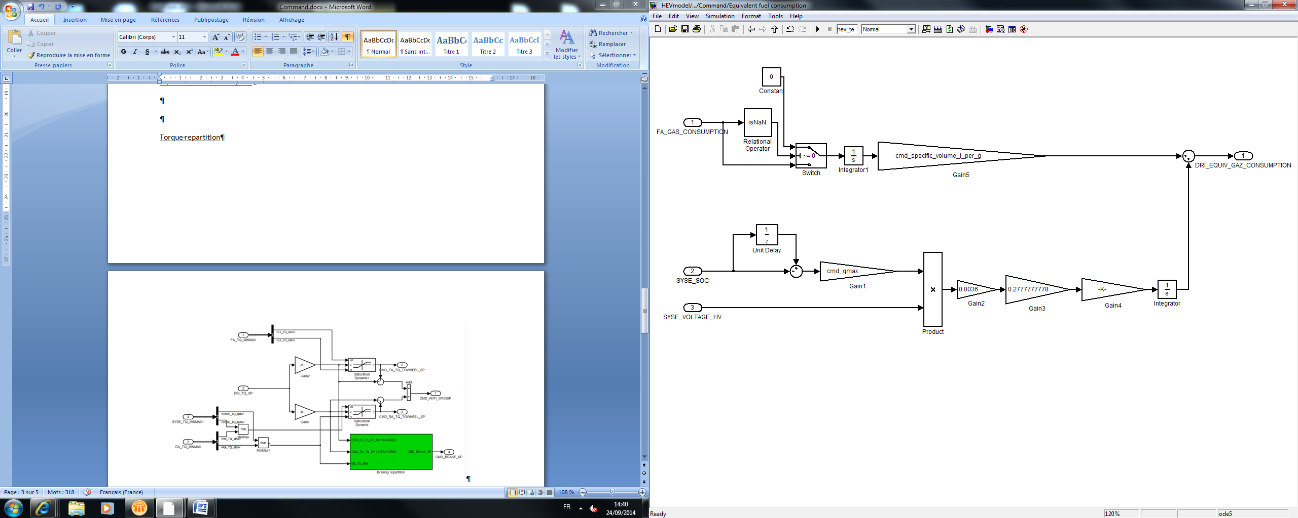

Start&stop prototype

Disables the ICE in low speeds and when GBX = 0.

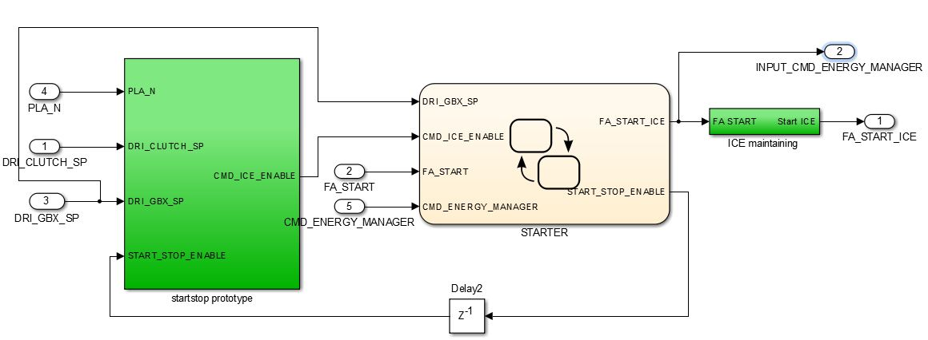

* Start Stop prototype: Design of the start and stop logic.
* STARTER: Synchronizes the Start/Stop with the Energy manager, and in the first start of the ICE.
* ICE maintaining: avoids short stops of the ICE.

Clutch Command:

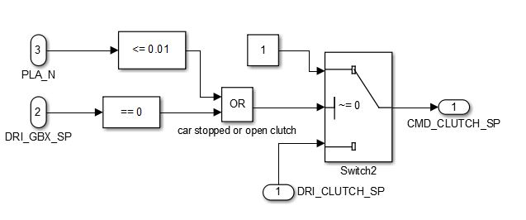

Imposes a clutch stuck when GBX = 0 or the speed is low.